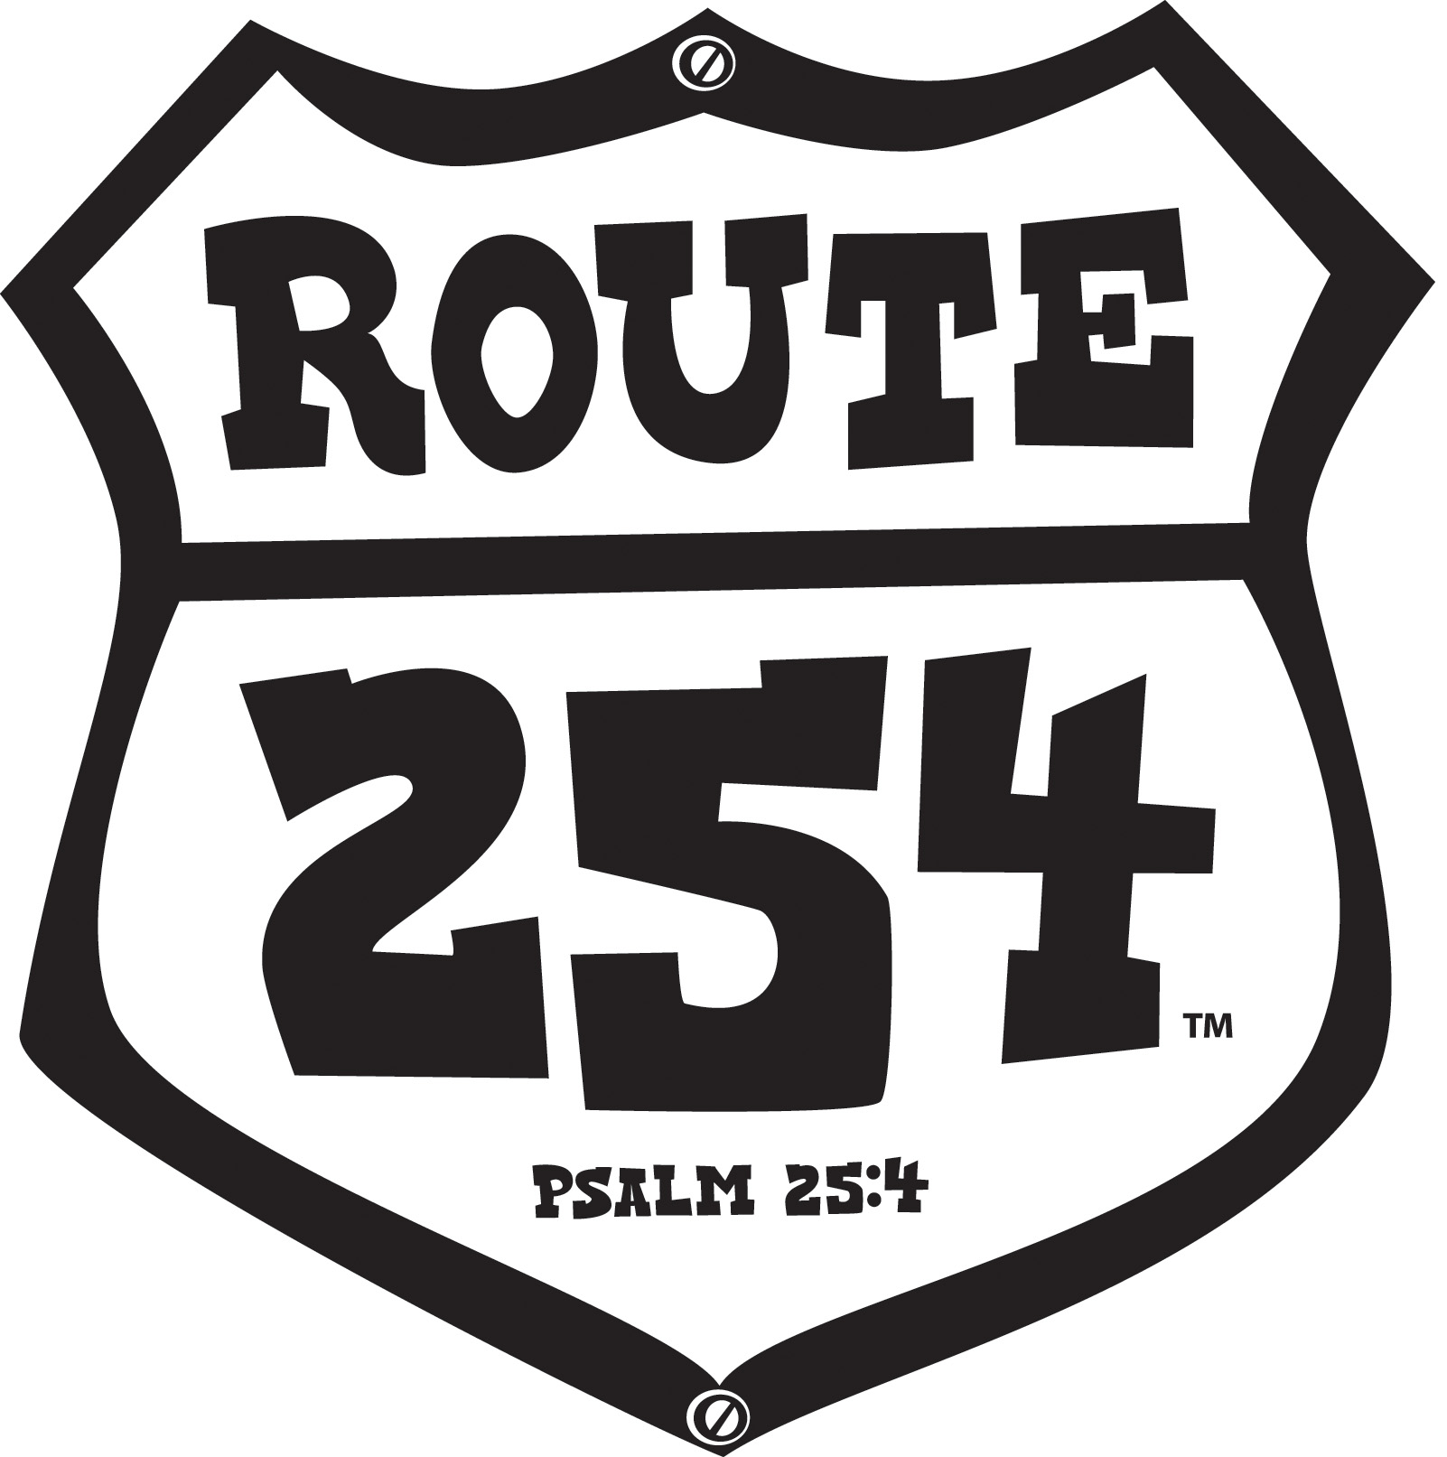

CLUB VBS 2010 Directors Base Conference Plan

Purpose Statement
This plan will be used to guide and encourage church leaders using LifeWay’s CLUB VBS 2010:Route 254 materials and resources.

Resources to Collect
- LifeWay’s CLUB VBS: Route 254 Starter Kit
- VBS 2010 catalog (available from your State Convention VBS promoter)
- VBS 2010 Helpful Facts Handout (available online www.lifeway.com/vbs)
- VBS 2010 Grice Memorial Mission VBS Fund brochure (available
online www.lifeway.com/clubvbs)
- VBS to Sunday School – an Enrollment & Growth Plan brochure (available
online www.lifeway.com/clubvbs)
- 8 ½ x 11 paper (color optional) one per conferee for semi-circles
- 3 pieces of 8 ½ x 11 cardstock for table tent
- Various colors poster board for making travel brochures

Focal wall, hallway and room decorations
- Tear sheets
- Markers
- 3 US maps
- Supplies for conferees to make a craft and/or snack (your choice)
- Supplies to play a recreation game (your choice)
- Snacks to place in conferees chairs – optional (Ex; popcorn, cracker jacks)

“Your choice” options are determined by budget, space, and time.

Resources to Prepare
- Know your Club VBS: Route 254 material and resources
- Print files found on Route 254 Administrative Guide CD-ROM and put in a three ring binder for conferees to view. If a laptop or CD/DVD player is available, place in the Bible Study campsite for viewing.
- Be ready to explain why and how to use CDs and DVDs that accompany the Route 254 material
- Make a table tent from 8 ½ x 11 cardstock. Attack the Route 254 logo to one side of tent. (Teaching Step 1) The road sign can be found on the Administrative CD-ROM or www.lifeway.com/clubvbs
- Attach assignment to the inside of Route 254 road sign tent (Teaching Step 1, Page 9).
- 2008 VBS stats (Teaching Step 2 – Pages 10 - 11) cut and laminate
- Write the name of Route 254 materials and resources on individual theme related die cuts. Place in Route 254 sampler luggage (Teaching Step 3)
- Travel brochure assignments (Teaching Step 4, Pages 12 - 13) Place in a theme bag.
- Print the following 5 topics on separate tear sheets: Evangelism; Safety;
Follow Up; Family Night; Promotion/Publicity/Planning (Teaching Step 5, handout page 14).

Pack supplies you will need for conference setup:

Conference outline
Conference handouts
Markers, pencils, pens
Scissors
Nametags
Medium that is acceptable for putting visuals on wall
Extra tablecloths to cover unrelated theme items in room
Candy or theme related favors for conferees

Pack your decorations and supplies in suitcases or in items that can become a part of your Route 254 props.

Resources to Copy
- Page 7 (1 copy per conferee)
- Page 8 (1 copy to prepare activity) Teaching Step 2
- Page 9 - 10 (1 copy to prepare activity) Teaching Step 4
- Page 11 – 12 (1 copy per group) Teaching Step 4
- Page 13 (1 copy per conferee) Teaching Step 4

Focal Wall Description
On the largest wall in the room, place a large colorful map of the Unites States.
(Item 2 from the Route 254 Children’s Leader Pack, Grades 4 – 6). The map can be mounted on foam board for stability. If using a generic map, clip art for the Route 254 logo can be found on the Administrative Guide CD-ROM or on the LifeWay VBS website: www.lifeway.com/clubvbs. Place a table about one foot in front of the map. Cover the table with black cloth and run a strip of extra wide yellow ribbon down the center of the black cloth to resemble a centerline. This table will display all of the Bible Study materials, Administrative Guide and other Club VBS: Route 254 LifeWay resources.

Room Setup Description
Arrange the chairs in three semi-circles. Leave openings for conferees to make their way to the sites. Place a US map on the floor in the center of each semi-circle. Place one 8 ½ x 11 piece of paper for each conferee. Place table tent (Prepare 4) on top of Map. Put one marker per conferee in each semi-circle.

Four additional areas will be created within the room to indicate rotation sites.
- Snack Diner
- Rec Park
- Crafts Souvenir Shop
- Route 254 Worship Rally

These areas can be created on the floor to save space or tables can be used if space permits. On these tables place additional Route 254 materials, samples of snacks, craft ideas, game/recreation supplies and simple and inexpensive ideas for theme decorations.

Decoration Suggestions

Using foam board or cardboard make a directional sign to set at the entrance of the classroom. Signs will reference and point in the direction of each of the sites. Cut and paint small trees from foam board to set at entrance and other areas of the room to add depth. Use maps and travel posters to promo theme. Route 254 promotional poster and window signs are available. Additional ideas can be found in the Route 254 Administrative Guide chapter 4.

Audio Visual Needs
- TV/DVD player
- CD player
- Laptop (optional)

Teaching Procedures:

Step 1 (5 minutes)
- Have Route 254 music playing
- Greet and welcome Tour Guides at the door
- Ask conferees to look around the room and be seated in one of the Route 254 sites and as a group follow directions found inside the Route 254 tent sign (Prepare 4). Give conferees three minutes to work on assignment.
- Ask each group to introduce themselves and share what they have discovered.

Say: “I think we have discovered that we each originate from various locations across the map and would make interesting recruiters for tourism for our hometown. As we travel Route 254 and share ideas, begin to map out what route you will take as you prepare for CLUB VBS.”

Step 2 ((5 minutes)
Say: “I would like to read Psalm 25:4 - 5 to you.
Make your way know to me, Lord, Teach me your path.
And verse 5 reads:
Guide me in your truth and teach me, for you are the God of my salvation.

As church leaders we often face many obstacles, but there is not one that we cannot overcome when we approach God and ask Him to reveal Himself to us; when we ask Him to show us His way; when we ask Him to guide us and teach us. When we do these things God will be glorified and honored through the VBS work into which He has called us. And as a result boys, girls, families and communities will come to know Jesus as Savior.”

Pray – Pray for the conferees and conference time together.

Say: “Look on the back of your chair, some of you will find the 2008 VBS report stats. As you are called upon please report the information.” (Prepare 6)

After conferees have shared their reports say: “Vacation Bible School is the single largest outreach event for most churches. More people have come to know Jesus through VBS than through any other single outreach event.” If time allows, give conferees an opportunity to share a church testimony as a result of VBS.

Step 3 (10 minutes)
Say: “Tour guides, what is your destination and what will you pack for your cross country road trip?” This time will be used to overview Club VBS: Route 254 materials. Pass Route 254 sampler luggage among conferees and let them select a card or die cut (Prepare 7). Have conferees place the card they have selected on the corresponding Route 254 material and resource item displayed around the room.

- Overview Route 254 sampler kit
Administrative Guide and CD-ROM
Worship Rally Guide
Worship Rally DVD/Enhanced CD
Music CD
Leader Guide for each age group
Learner Guide for each age group
Samples of promotional pieces
- Review items that can be purchased separately
All Club VBS: Route 254 resources, with the exception of the Administrative
Guide, can now be purchased separately
- Review new items
- Review free resources
*Adult VBS materials are available online as a free download
(www.lifeway.com/clubvbs
*Missions Stories are available online as a free download (www.lifeway.com/clubvbs)

Step 4 ((10 minutes)
Say: “Enlisting leaders for VBS is often a challenge. Who do we get? Where do we get them? Once we get them, what do we do with them?” You will need seven groups, divide according to the number in conference. Ask someone from each group to come up and choose an assignment from theme bag (Prepare 8).

Allow approximately five minutes to complete the assignment. Tell conferees the supplies for making their travel brochure can be found in the Crafts Souvenir Shop. Ask conferees to be prepared to share their travel brochure designs when called upon. Allow one minute per group for sharing their ideas.

If conferees are not familiar with Route 254 terms used in their assignment direct them to page 5 of the Administrative Guide for a glossary of terms.

As conferees work on their assignments play Route 254 Music CD softly.

Be prepared to bring attention to specific characteristics of enlisting leaders that may not be mentioned. Refer to pages 14 and 15 of Administrative Guide.

Say: “Enlisting the right tour guides for our Ramblers is crucial and the training we provide our tour guides is vital. We must equip, train, encourage and set high expectations…. and most importantly we need to pray for those leaders.” Refer to Road Trip Training on page 16 – 19 of Administrative Guide.

Step 5 (15 minutes)
Ask conferees to move to one of the five travel posters (tear sheets) of their choice.
Say: “Posted on the walls you will find travel posters (tear sheets). On these posters are important VBS topics of concern and when addressed correctly help lead us to a successful VBS. As a group, using Route 254 resources and your personal experiences, list ways that will address these topics. When you hear the music stop, remain standing and be ready to discuss what you have discovered” (Prepare 9).

Allow five minutes for this assignment. As conferees work on their assignments play Route 254 Music CD softly.

Have each group share how they would address these topics. Allow 2 – 3 minutes, per topic, for discussion.

Hand out Page 14 to conferees.

Step 6 (10 minutes)
Say: “As our cross country road trip comes almost to an end let’s cruise the last few miles of Route 254 together.” Invite conferees to view each of the sites. If the group is small you may move around the room together, however, if the group is large conferees will have to remain in their seats.

- Route 254 Worship Rally - Have Worship Rally DVD ready for viewing.
- Bible Study Campsite – Display Bible Study materials. Refer to the locations that will be visited each day during Club VBS: Route 254.
- Crafts Souvenir Shop – Display a sample of daily crafts. Refer to Chapter 5 of the Administrative Guide.
- Rec Park – Display a small selection of game supplies. Refer to Chapter 6 of the Administrative Guide.
- Snacks Diner – Display a sample of daily snack items. Offer a Route 254 snack if possible. Refer to Chapter 7 of the Administrative Guide.

Give conferees an opportunity to ask questions.

Step 7 (5 minutes)
Say: “I have enjoyed cruisin’ Club VBS: Route 254 with you today. It has been a fun and exciting road trip. What a joy to share Jesus with boys and girls, their families and communities. I will be praying for you as you continue on with your Route 254 road trip.”

Close with your personal thoughts and prayer.

As conferees leave stand at the door and thank each one for cruisin’ Route 254 with you.



Cruisin' Route 254

.
.
.
.
.
.

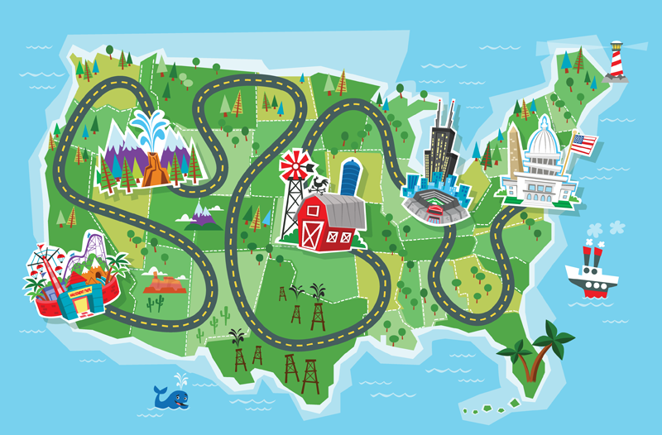
Using items in the bag, make an outline of the US map by placing paper BEHIND your back.

When called upon, show your artwork, introduce yourself and your hometown with an adjective that begins with the first letter of your hometown. (EX. I am Messy Linda from Marvelous Mt. Carmel.)
Using items in the bag, make an outline of the US map by placing paper BEHIND your back.

When called upon, show your artwork, introduce yourself and your hometown with an adjective that begins with the first letter of your hometown. (EX. I am Messy Linda from Marvelous Mt. Carmel.)
Using items in the bag, make an outline of the US map by placing paper BEHIND your back.

When called upon, show your artwork, introduce yourself and your hometown with an adjective that begins with the first letter of your hometown. (EX. I am Messy Linda from Marvelous Mt. Carmel.)

In 2008 over 37,000 people were enrolled in Sunday School as a result of VBS.
Vacation Bible School is the single largest outreach event for most churches.
More people have come to know Jesus as Savior through VBS than through any other single outreach event.
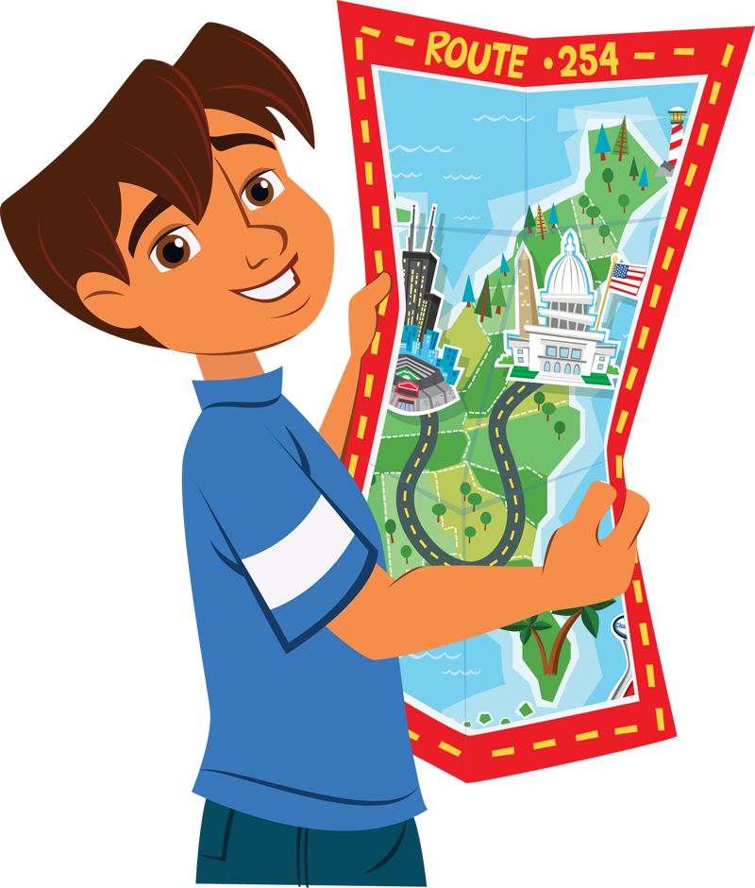
In 2008 over 2,850,000 people were enrolled in VBS.
In 2008 over 86,000 decisions to accept Christ were reported as a result of VBS.
In 2008 more than 3,200 people committed their lives to church related vocations during VBS.
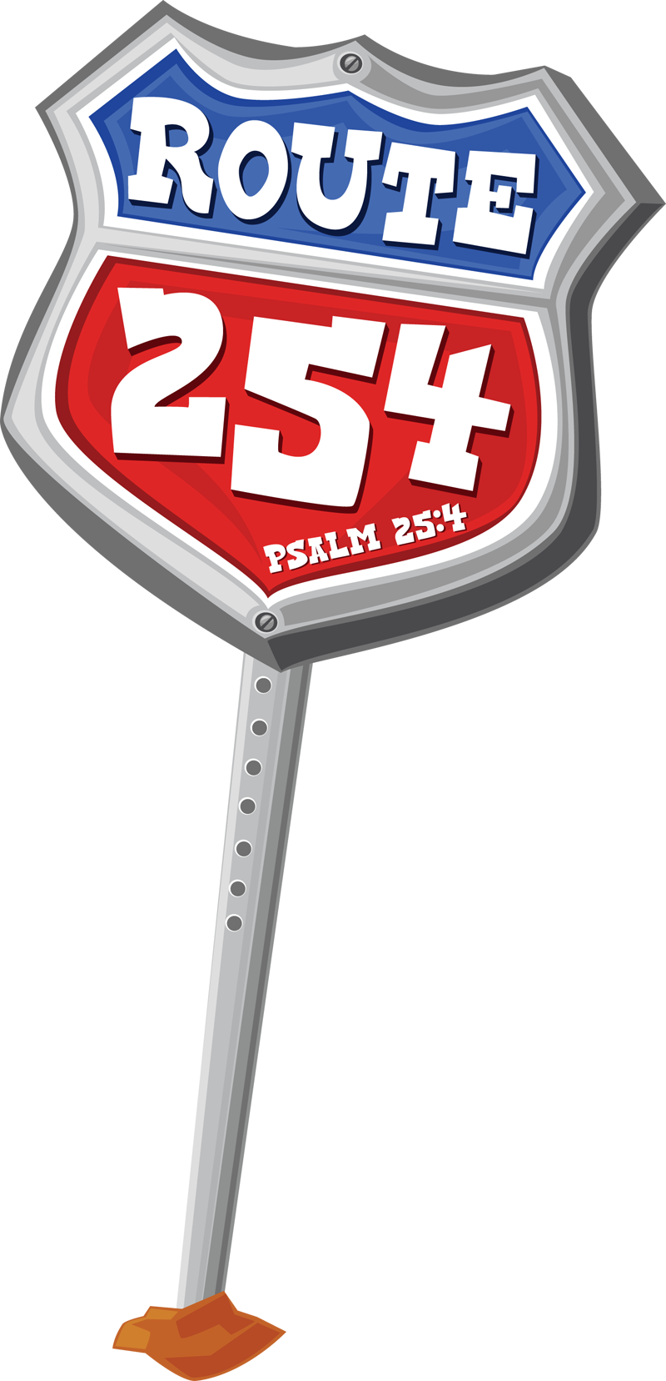
As a group, create a travel brochure to enlist Rotation Site Tour Guides for cruisin’ Rec Park in Club VBS Route 254. Page 14 and 15 of the Administrative Guide may be helpful in creating your design.

When the music stops, be prepared to share your design and one tour guide training idea.

As a group, create a travel brochure to enlist Rotation Site Tour Guides for cruisin’ Snack Diner in Club VBS Route 254. Page 14 and 15 of the Administrative Guide may be helpful in creating your design.

When the music stops, be prepared to share your design and one tour guide training idea.

As a group, create a travel brochure to enlist team members to lead Club VBS Route 254 Worship Rally. Page 14 and 15 of the Administrative Guide may be helpful in creating your design.

When the music stops, be prepared to share your design and one tour guide training idea.

As a group, create a travel brochure to enlist a Travel Agent for Club VBS Route 254. Page 14 and 15 of the Administrative Guide may be helpful in creating your design.

When the music stops, be prepared to share your design and one tour guide training idea.
As a group, create a travel brochure to enlist Rambler (children) Tour Guides for Club VBS Route 254. Page 14 and 15 of the Administrative Guide may be helpful in creating your design.

When the music stops, be prepared to share your design and one tour guide training idea.
As a group, create a travel brochure to enlist Rotation Site Tour Guides for cruisin’ Crafts Souvenir Shop in Club VBS Route 254. Page 14 and 15 of the Administrative Guide may be helpful in creating your design.

When the music stops, be prepared to share your design and one tour guide training idea.

As a group, create a travel brochure to enlist Rambler (preschool) Tour Guides for Club VBS Route 254. Page 14 and 15 of the Administrative Guide may be helpful in creating your design.

When the music stops, be prepared to share your design and one tour guide training idea.



Cruisin' Route 254 with . . .

- Evangelism

- Safety

- Follow-up

- Family Night

- Promotion / Publicity / Planning

